Title of the presentation

# *Author1 First Name Author1 Last Name (Author1 affiliation), Author2 First Name Author2 Last Name (Author2 affiliation)…*

**Presentation type**

Collaboration proposal | On-going collaborative work | Result of research work

**Keywords**

Keyword 1, Keyword 2, …. Keyword n.

**Introduction**

Normal text in a normal paragraph. Normal text in a normal paragraph. Normal text in a normal paragraph. Normal text in a normal paragraph. Normal text in a normal paragraph. Normal text in a normal paragraph. In the aerospace domain, some works are addressing hybrid Artificial Intelligence (AI) for fault diagnosis (1) and explainable AI for maintenance (2).

**A section**

Normal text in a normal paragraph. Normal text in a normal paragraph. Normal text in a normal paragraph. Normal text in a normal paragraph. Normal text in a normal paragraph. As shown in Figure 1, it is a brain, a printed circuit board and an aircraft.

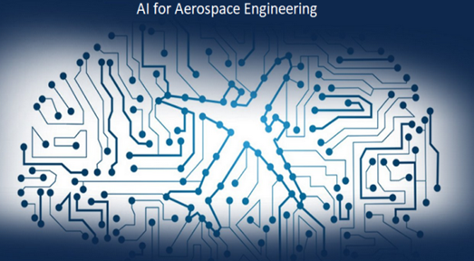

Figure 1: Caption of the figure

Another paragraph. Normal text in a normal paragraph. Normal text in a normal paragraph. Normal text in a normal paragraph. Normal text in a normal paragraph.

**Another section**

Another paragraph. Normal text in a normal paragraph. Normal text in a normal paragraph. Normal text in a normal paragraph. Normal text in a normal paragraph. Figure 1 presents concepts related to brain, printed circuit board and aircraft.



Figure 2: Caption of another figure

Another paragraph. Another paragraph. Another paragraph. Another paragraph. Another paragraph. Another paragraph.

Another paragraph. Another paragraph. Another paragraph. Another paragraph. Another paragraph. Another paragraph.

**Conclusion**

Another paragraph. Another paragraph. Another paragraph. Another paragraph. Another paragraph. Another paragraph.

|  |
| --- |
| **References:**   1. Ezzat D, Hassanien AE, Darwish A, Yahia M, Ahmed A, Abdelghafar S. Multi-objective hybrid artificial intelligence approach for fault diagnosis of aerospace systems. IEEE Access. 2021 Mar 9;9:41717-30.      1. Shukla B, Fan IS, Jennions I. Opportunities for explainable artificial intelligence in aerospace predictive maintenance. InPHM Society European Conference 2020 Jul 19 (Vol. 5, No. 1, pp. 11-11).   Note : References are in Vancouver style |